**ME 111 Engineering Drawing**

**Section of solids Friday Batch**

**Q.1** A cone with base 75 mm diameter and axis 80 mm long is resting on its base on H.P. It is cut by a section plane perpendicular to the V.P., inclined at 45º to the H.P. and cutting the axis at a point 35 mm from the apex. Draw the front view, sectional top view, sectional side view and true shape of the section. [20 marks]

{Note: Please don’t cut the marks if the student divides the base circle into 6 or 8 equal number of parts. Dividing the circle into 4 equal parts is not to be accepted as 4 points are not sufficient to give the proper views of sections.}

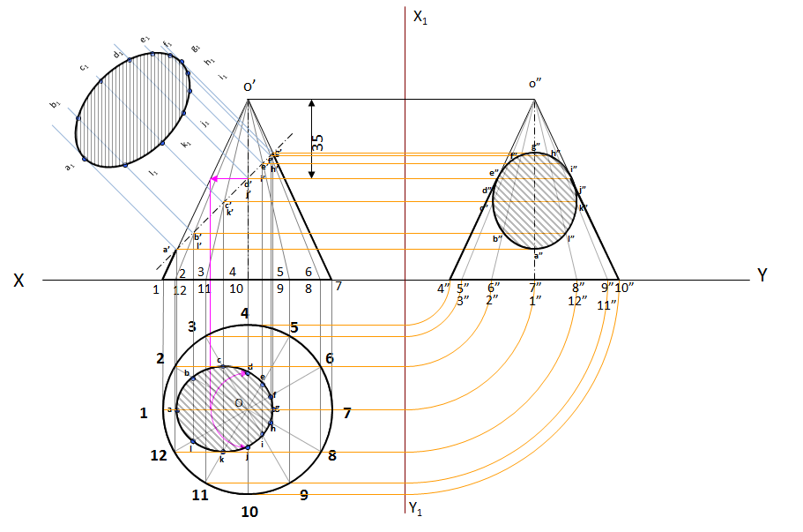

**Q.2** A hexagonal prism with base 25 mm and height 65mm has a face on the H.P. and the axis is parallel to the V.P. It is cut by a vertical section plane, the H.T. of which makes an angle of 45° with XY and which cuts the axis at a point 20 mm from one of its ends. After cutting, if the smaller cut-part is removed, then draw sectional front view of the remaining solid and the true shape of the section. [30 marks]



